**Zebrunner Automation reporting**

* Create the new Account in the Zebrunner while creating new Account choose “**Automation Reporting”** don't choose any other trail pack otherwise you will face the Authentication error while sending the report
* After putting your details, you will get one mail from the Zebrunner team and in that mail, they will give your zebrunner link and some credentials. After putting in the credentials, you will redirect to the homepage of the Zebrunner.
* In your **Maven project** in pom.xml you must add one dependency that is “**TestNG Agent”** this dependency you will get in maven repository [**Website Link**](https://mvnrepository.com/artifact/com.zebrunner/agent-testng)
* You must check that which TestNG version is Compatible with TestNG agent
* Here is the maven dependency and the compatible version

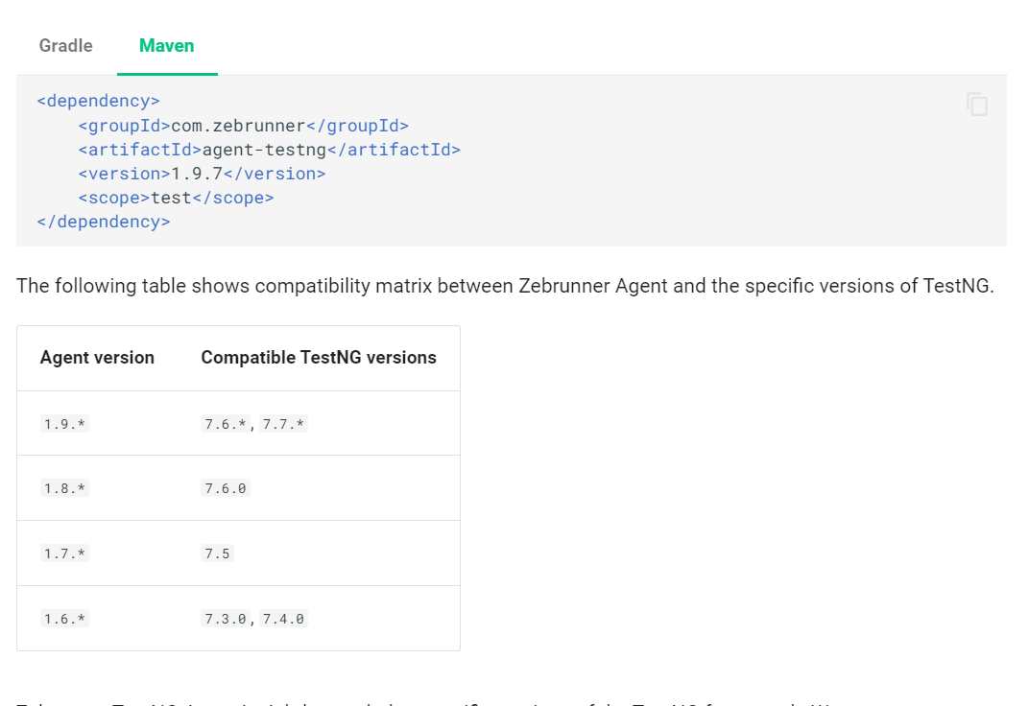

* After adding the dependency, you must add one file in the **resource** folder (if folder is not present you can create one resource folder in the src/test)
* In the resource folder you must create one file that **“agent.properties”**
* After this go back to your zebrunner homepage you can see one option in top right **Getting Started**
* After click on Getting Started you will get this interface

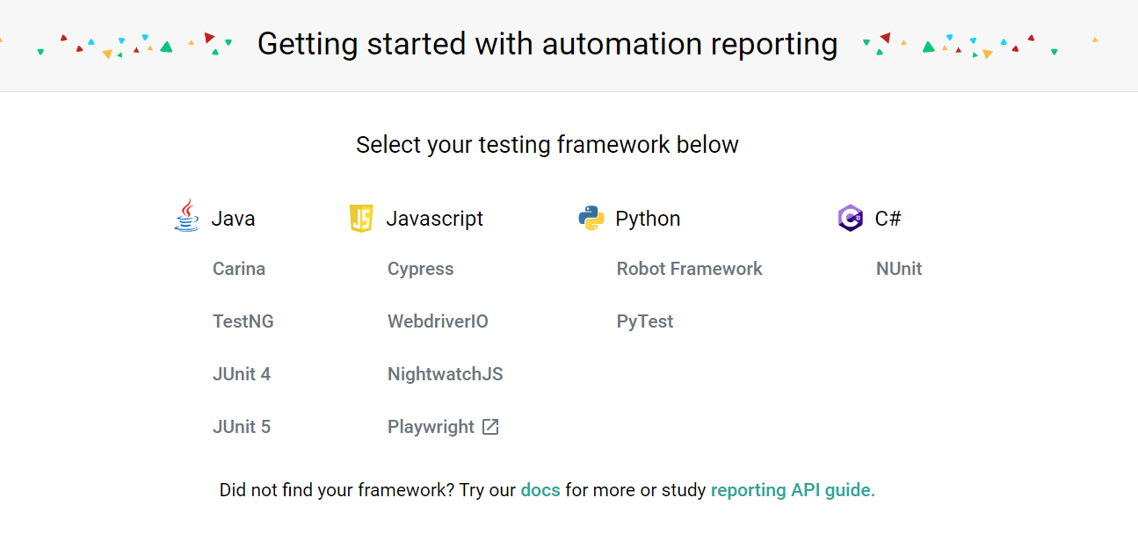

* After this from the given option if you are using other programming language then you can select according to your need, here in this case we are using the java selenium, so I'm using the **TestNG**
* After clicking on the TestNG you will get one new interface, from that interface you have to take the agent.properties which is used for credentials and reporting

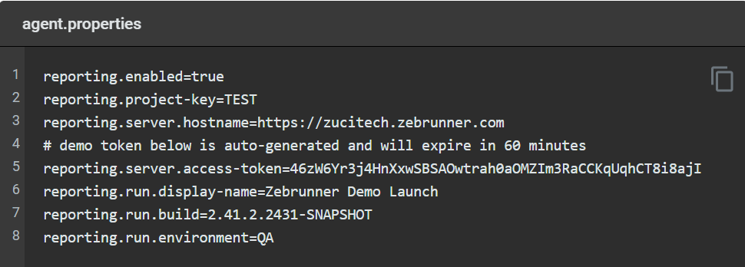

* Copy the code and paste in your maven project in agent.properties
* You must change the server access token for that you can go to your profile and in that you will have one option **API Token create**
* Create one new token copy that token and paste that token in the agent.properties reporting.server.access-token= <your token>
* After that you have to go to the pom.xml and one resource path as given below

<resources>  
 <resource>  
 <directory>src/test/resources</directory>  
 <includes>  
 <include>**/*.properties</include>  
 </includes>  
 </resource>  
</resources>

* After that rebuild your project use terminal and follow the command

mvn clean install

* After this save everything and run your Testng.xml file you will get your test results on zebrunner
* For more details you can see the [Zebrunner Document](https://zebrunner.com/documentation/reporting/carina-testng/)
* For YouTube video you can watch this video [Youtube Link](https://www.youtube.com/watch?v=qIJRymc8mo0)